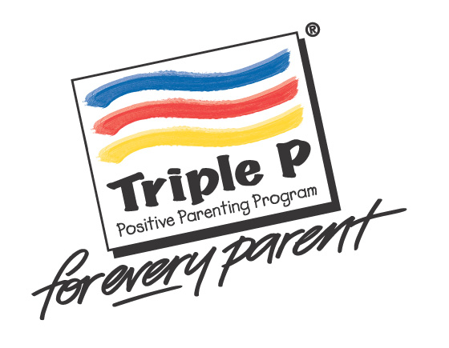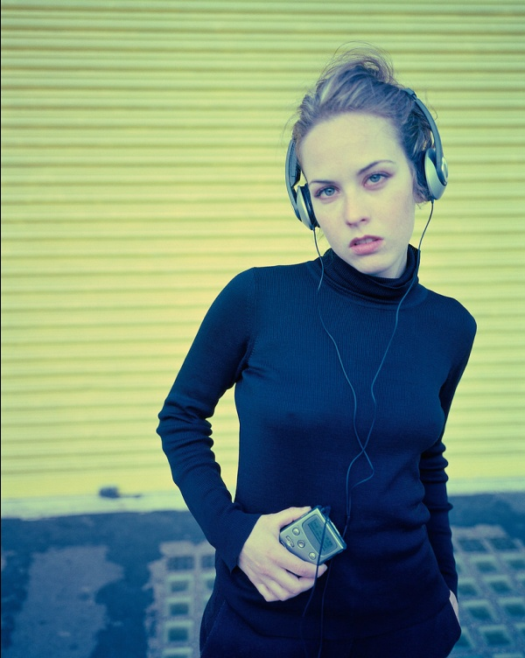 Positive Parenting Programme
Teenagers don’t come with an instruction manual!

Triple P works for all kinds of families, in all kinds of circumstances, with all kinds of problems.

Triple P is a system of easy to implement, proven parenting solutions that help solve current parenting problems (including emotional behaviour and risky situations), and prevents future problems before they arise.

Triple P is flexible, so you can do as little or as much as you want. You decide what you need then pick and choose what suits you! The course runs for 5 weeks as a group, then we will support you for 3 weeks in implementing your chosen strategies at home, then back together for the last session to see how it went!

FREE (8-week) course for parents:-

Teen Triple P:- For parents / carers of children aged 11-16 years
Starting:- Wednesday 27th April 2011, (12.45pm – 2.45pm)
End Date:- Wednesday 22nd June 2011, (12.45pm – 2.45pm)
Venue:- Firth Park Community Arts College, Fircroft Avenue

For more information or to book a place, please contact:

Clare Fairclough / Katie Powell / Kerry Robinson Tel:- 0114 257 4027 / 257 6238

