The Youth Offending
Service is moving

From Monday 26 March
our new location will be
Star House, 43 Division Street
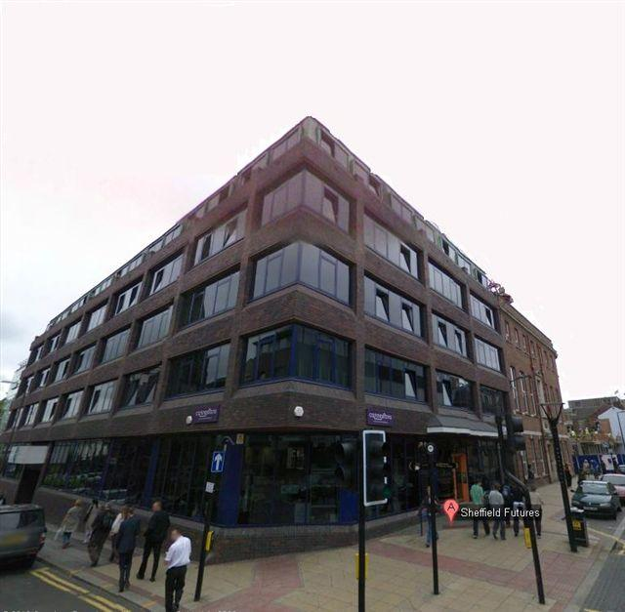
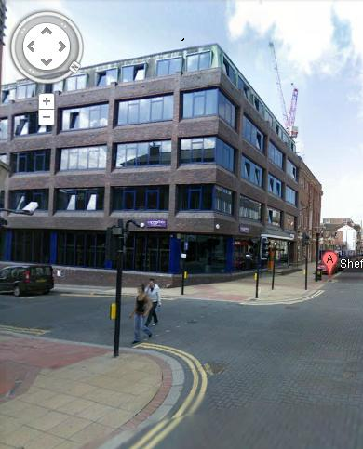

7 St Peters Close will close at 12.00 pm on Friday 23 March

